1.0 Building the Development Environment 2
2.0 How to Compile the Monitoring Suite 4
2.1 Promotion Process 4
2.2 Promotion Process 5
2.2.1 Compiling on each platform (Windows/Solaris/Linux) 5
2.2.2 Running the test suite for the tools 5

1.0 Building the Development Environment

- Download and install ActivePerl 5.8.8-build 816 or later.
An optional step is to install ActiveState Komodo. The workspace file is called
$CVSROOT/vpo/vpo-komodo.kpf

- Install the ActiveState Perl Development Kit v5.3
This will install the “perlapp” compiler.

Installer is located at
\\esm\setup\ActiveState-Software\Perl Dev Kit\PDK53

License file is located under
\\esm\setup\ActiveState-Software\Licenses\Perl Dev Kit

- Set the environment variable HTTP_proxy to http://webproxy:80
As you move go through the steps, you may discover that you need to install additional Perl packages from CPAN. Setting this environment variable allows ppm3 to connect to the outside world to download and install them.

- Go to ppm to install Mail-SendMail
If this package is missing, the automatic installer won’t work.

- Run “perl $CVSROOT/vpo/utilities/active_perl_util.pl –install”
This is the automatic script that downloads and installs

- Make sure that the Openview server knows about your development machine
- You can find a list of Openview servers at http://esm/admin
- Login with portal_adm/portal_AdM credentials
- Click on “Add Nodes” in the left menu
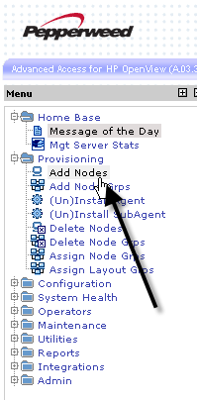
- The right half of the browser would have changed. Please change the parameters in the page to look like the following

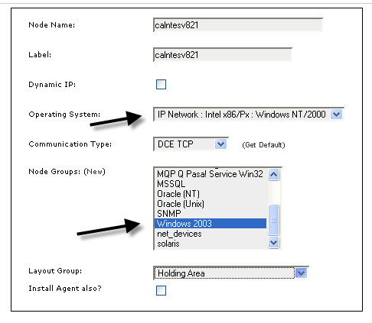

- Install the HP Openview Agent on your machine

- The installer is in \\esm\vpo-agents\VPO Agent for Windows v7.30 . Copy to a temporary directory on your machine. Call this $TEMP_DIR
- Modify $TEMP_DIR\opcsetup.inf to point to vpo-dev (at time of writing, was rmcuxsrv049.insidelive.net)
- Run opc_inst.bat

2.0 How to Compile the Monitoring Suite

2.1 Promotion Process

OVO Server
Windows
Solaris
Linux
New versions of the Self-Service Monitoring (SSM) tools to each Openview Agent are distributed by dropping the binaries into the agent distribution directory. Therefore, the entire distribution process consists of the following steps:

- Build the SSM tools on each platform (Windows/Solaris/Linux)
- From each build platform, check the binaries into CVS
- On the management server, check the binaries out into the agent distribution directory
- Ask the OVO server to distribute the binaries

2.2 Promotion Process

2.2.1 Compiling on each platform (Windows/Solaris/Linux)

Under $CVSROOT/SSM/compile, run the command

perl ssm2_compile.pl –p=$MONITOR_NAME

You can retrieve the list of all monitor names by running the command

perl ssm2_compile.pl –-list

2.2.2 Running the test suite for the tools
Each SSM tool comes with its own automatic test suite, all based on the TestMore library. These test suites are located under $CVSROOT/SSM/t. To run these test suites, you need to do the following:

- Disable the Openview templates on the build machine
This prevents the build machine from creating events that result from running the test suite.

- Generate the configuration file for the test suite
This generates all the test cases for the next step. The script is located at

$CVSROOT/SSM/t/SSM-AlertConfigGen-$MONITOR_NAME.pl

- Execute the monitor.
This will read all the test cases from the previous step and execute each case. The script is located at

$CVSROOT/SSM/bin/$MONITOR_NAME/$PLATFORM

- Execute the data validation script for the test suite
This validates the results of the previous step.

$CVSROOT/SSM/t/SSM-DataValidate-$MONITOR_NAME.pl

- Re-enable the Openview templates on the build machine

